Bachelor of Science in Computer Science & Engineering



"Secure Electronic Voting System Using Biometric Authentication and AES Encryption"

Submitted by
MD. ARIF
ID: 666-60-04
MD. MAINUL ISLAM
ID: 666-60-24

Supervised by
MOHAMMAD JAHANGIR ALAM
Associate Professor, depts. Of CSE

Department of Computer Science & Engineering
Southern University Bangladesh
New/471, University Road, Arefin Nagar, Chattogram, Bangladesh

JULY, 2026

Department of Computer Science & Engineering

Southern University Bangladesh
New/471, University Road, Arefin Nagar, Chattogram, Bangladesh

Thesis/Project Proposal
Application for the Approval of B.Sc. Engineering Thesis/Project

Student Name  ID  Student Name  ID | : MD . ARIF  : 666-60-04  : MD. MAINUL ISLAM  : 666-60-24
Supervisor  Designation | : MOHAMMAD JAHANGIR ALAM  : Associate Professor  Department of Computer Science & Engineering
Department  Program | : Computer Science & Engineering  : B.Sc. Engineering

Tentative Title : Secure Electronic Voting System Using Biometric Authentication and AES Encryption.
Table of Contents

Contents | Page No.
Table of Contents | i
List of Figures | ii
List of Tables | iii
List of Abbreviations | iv
1 Introduction | 1
1.1 Problem Statement | 3
1.1.1 Research Motivation | 4
2 Literature Review | 5
3 Objectives and Possible Outcomes | 7
3.1 Objectives | 7
3.2 Expected Outcomes | 7
4 Impact Identification | 8
4.1 Social and Cultural Impact | 8
4.2 Environmental Impact | 8
4.3 Sustainability Plan | 9
5 Outline of Methodology | 10
5.1 Proposed System Architecture | 10
5.2 Face Verification Workflow | 12
5.3 Secure Voting Process | 14
6 Applications | 16
7 Required Resources | 18
7.1 Required Tools | 18
8 Cost Estimation | 19
8.1 Time Management | 19
References | 20
List of Figures

Figure No. | Description | Page No.
Figure 5.1 | Proposed System Architecture | 11
Figure 5.2 | Face Verification Workflow | 13
Figure 5.3 | Secure Voting Process | 15

List of Tables

Table No. | Description | Page No.
Table 2.1 | Comparison of Existing Voting Systems | 5
Table 7.1 | Required Software and Hardware Resources | 18
Table 8.1 | Cost Estimation | 19
Table 8.2 | Project Timeline (Gantt Chart) | 19

List of Abbreviations

Abbreviation Full Form
AES | Advanced Encryption Standard
AI | Artificial Intelligence
API | Application Programming Interface
DBMS | Database Management System
DFD | Data Flow Diagram
GUI | Graphical User Interface
HTTP | Hypertext Transfer Protocol
JSON | JavaScript Object Notation
MySQL | My Structured Query Language
NID | National Identity Number
REST | Representational State Transfer
SQL | Structured Query Language
UI | User Interface
UX | User Experience
OTP | One-Time Password
CPU | Central Processing Unit
RAM | Random Access Memory
HTTPS | Hypertext Transfer Protocol Secure

1. Introduction
The increasing use of digital technology has transformed many traditional processes, including communication, education, banking, and governance. Voting is one of the most important democratic activities that can also benefit from technological advancement. Electronic voting systems have emerged as an effective alternative to conventional paper-based voting because they simplify election management, reduce manual effort, and enable faster vote counting and result publication [1], [2]. Despite these advantages, concerns regarding voter authentication, vote security, and data privacy continue to limit the widespread adoption of electronic voting systems [3], [4].
In many educational institutions, organizations, and developing countries such as Bangladesh, elections are still conducted using traditional paper-based methods. These manual processes often require considerable time and effort for voter verification, vote counting, and result preparation. Furthermore, they are susceptible to human error, voter impersonation, duplicate voting, and administrative inefficiencies [5], [6]. Consequently, there is an increasing demand for a secure and efficient electronic voting platform capable of accurately verifying voters while protecting sensitive election data.
One of the most important requirements of any electronic voting system is ensuring that only eligible voters are allowed to cast their votes. Conventional authentication methods, including passwords, identity cards, and personal identification numbers (PINs), can be lost, stolen, shared, or forged, making them insufficient as the sole means of voter verification [7], [8]. To overcome these limitations, biometric authentication has attracted significant attention because biometric traits are unique to each individual and difficult to replicate. Among various biometric technologies, facial recognition has become particularly popular due to its convenience, non-intrusive nature, and compatibility with widely available camera devices [9].
In this research, facial recognition is employed as the primary voter authentication mechanism. The proposed system utilizes the DeepFace framework, a deep learning-based facial recognition model, to verify voter identities before granting access to the voting interface [10]. During voter registration, a facial image is securely stored in the database. When a voter attempts to cast a vote, the system captures a live image using a webcam and compares it with the stored facial image. Access is granted only when the similarity score exceeds a predefined threshold. This process helps prevent voter impersonation while reinforcing the principle of "one person, one vote" [11].
Besides voter authentication, protecting voting data is equally essential for maintaining election credibility. Electronic voting systems store and process sensitive information, including voter records, candidate details, and voting results. Any unauthorized disclosure or modification of this information may compromise the integrity of the election [12]. Therefore, robust encryption techniques are necessary to ensure the confidentiality and integrity of election data throughout the voting process.
To enhance data security, the proposed system employs the Advanced Encryption Standard (AES), one of the most widely adopted symmetric encryption algorithms in modern information security [13]. AES was selected because of its strong security, computational efficiency, and resistance to various cryptographic attacks. Before voting records are stored in the database, they are encrypted using AES, minimizing the risk of unauthorized access, modification, or data tampering [14].
The complete voting platform is developed using Flutter, FastAPI, and MySQL. Flutter provides a responsive and user-friendly interface, while FastAPI manages voter authentication, facial verification, vote processing, and communication between different system components. MySQL is used as the database management system to store voter information, election data, and encrypted voting records [15]. The integration of these technologies results in a practical, efficient, and secure electronic voting solution.
Unlike many existing electronic voting systems that rely solely on conventional authentication methods, the proposed system combines biometric facial verification with cryptographic data protection. This integrated approach addresses two critical challenges simultaneously: ensuring that only authorized voters can participate and safeguarding election data from unauthorized access or manipulation. By integrating DeepFace-based facial recognition with AES encryption into a unified platform, the system aims to provide a secure, reliable, and efficient voting environment.
In conclusion, this research presents a secure electronic voting system that combines biometric authentication and AES encryption to enhance voter verification, protect election data, and improve overall election integrity. The proposed solution contributes to the development of trustworthy digital voting systems and supports the future adoption of secure electronic elections in educational institutions, organizations, and broader governance applications.

1.2 Problem Statement
Electronic voting systems are increasingly used in universities and organizations to improve election efficiency. However, many existing systems still rely on traditional authentication methods such as usernames, passwords, student IDs, or voter identification cards. These methods are relatively easy to misuse because credentials can be shared, stolen, forgotten, or forged. As a result, unauthorized individuals may gain access to the voting system, creating opportunities for voter impersonation and compromising the fairness of election results.
In many university and organizational voting systems, voter verification is performed manually or through basic login credentials. While these approaches are simple to implement, they do not provide strong proof that the person casting a vote is actually the registered voter. Consequently, the risk of fraudulent participation remains a significant concern. Furthermore, some existing systems lack effective mechanisms for preventing duplicate voting, which may allow a voter to submit multiple votes intentionally or unintentionally.
Another challenge is the security of voting data. Modern electronic voting systems store sensitive information, including voter identities, candidate information, and voting records, in digital databases. If these records are not adequately protected, they may be vulnerable to unauthorized access, modification, or cyberattacks. Any compromise of election data can damage the credibility of the election process and reduce voter confidence in the system.
Several existing voting platforms focus primarily on improving election efficiency but provide limited integration of biometric authentication and secure data encryption within a single system. As a result, there remains a gap in developing a voting solution that can simultaneously verify voter identity with high accuracy and protect election data from unauthorized access or tampering.
To address these limitations, this research proposes a Secure Electronic Voting System Using Biometric Authentication and AES-256 Encryption. Facial recognition is selected as the authentication method because it provides a convenient and non-intrusive way to verify voter identity using unique facial characteristics. The DeepFace framework is adopted due to its strong face verification performance, support for multiple deeplearning models, and ease of integration into real-world applications. By comparing a live facial image with the voter's registered image, the system can significantly reduce the risk of impersonation and unauthorized voting.
For data protection, AES-256 encryption is employed to secure sensitive voting information before storage and transmission. AES-256 was selected because it offers a high level of security, efficient performance, and widespread acceptance in modern information security applications. The use of AES-256 helps protect voting records from unauthorized access, modification, and potential cybersecurity threats.

Therefore, the proposed system aims to fill the gap in existing university and organizational voting platforms by combining biometric voter verification, duplicatevote prevention, and strong encryption mechanisms within a single framework. The system is designed to improve election security, strengthen voter authentication, protect sensitive data, and increase trust in the overall electronic voting process.

1.1.1 Research Motivation
The rapid advancement of information and communication technologies has transformed various aspects of modern society, including governance, public administration, education, healthcare, and financial services. As governments and organizations increasingly adopt digital solutions to improve efficiency and accessibility, there is a growing demand for secure and reliable electronic voting systems. Electronic voting has the potential to reduce administrative costs, speed up election processes, minimize human errors, and provide faster result generation. However, concerns regarding security, voter authentication, privacy protection, and election integrity continue to hinder the widespread adoption of digital voting technologies.
One of the primary motivations behind this research is the increasing threat of election fraud and identity-related attacks in both traditional and electronic voting systems. Conventional authentication techniques, such as voter cards, passwords, or manual identity verification, may be vulnerable to impersonation, duplication, and unauthorized access. Such weaknesses can compromise the credibility and fairness of election outcomes. Therefore, stronger mechanisms are required to verify voter identity accurately and ensure that only legitimate voters participate in the election process.
Biometric authentication has emerged as a promising solution for enhancing security in critical applications. Among various biometric techniques, facial recognition is particularly attractive because it is non-invasive, user-friendly, and capable of providing real-time identity verification. The integration of artificial intelligence and deep learning technologies has significantly improved the accuracy and reliability of facial recognition systems, making them suitable for secure authentication in electronic voting environments.
This research is motivated by the need to develop a comprehensive security framework that combines biometric authentication and cryptographic protection within a single electronic voting platform. By integrating facial recognition for voter verification and AES encryption for data security, the proposed system aims to provide a secure, transparent, efficient, and trustworthy voting environment. Furthermore, the project seeks to contribute to the advancement of digital governance by demonstrating how modern technologies can be utilized to strengthen democratic processes and improve public confidence in electronic voting systems.
The successful implementation of this system has the potential to reduce election fraud, prevent duplicate voting, enhance voter authentication, protect sensitive informationand support the future adoption of secure electronic voting technologies on a larger scale.

2. Literature Review
Electronic voting has become an important research area due to the growing demand for faster, more efficient, and secure election processes. Researchers have proposed various electronic voting solutions to reduce the limitations of traditional paper-based elections, such as lengthy vote counting, administrative costs, and human errors. Despite these advantages, concerns regarding voter authentication, vote confidentiality, and election integrity continue to challenge the adoption of electronic voting systems.
One of the primary areas of research in electronic voting is voter authentication. Traditional authentication methods, including identification cards, passwords, and manual verification procedures, have been criticized for their vulnerability to impersonation and unauthorized access. To overcome these limitations, several researchers have introduced biometric authentication techniques into voting systems. Biometric methods utilize unique human characteristics, making them more reliable than conventional credentials that can be lost, stolen, or shared.
Facial recognition has received considerable attention among biometric technologies because it can authenticate users without requiring physical contact with specialized hardware. Taigman et al. [10] introduced DeepFace, a deep learning-based facial recognition model that achieved remarkable accuracy in face verification tasks. Their work demonstrated the effectiveness of deep neural networks in extracting and comparing facial features. However, the study primarily focused on recognition performance and did not address the specific security requirements of electronic voting applications. In contrast, the proposed system applies DeepFace within a voting environment to verify voter identity before vote submission.
Similarly, Schroff et al. [16] developed FaceNet, a face recognition framework that generates compact facial embeddings for identity verification and recognition. The model achieved high accuracy while reducing computational complexity compared to earlier approaches. Although FaceNet has been successfully applied in many authentication systems, the research was not designed to prevent election fraud or secure voting records. Therefore, additional security measures are necessary when deploying facial recognition within a voting platform.
Apart from voter authentication, the security of voting records has been another major area of research. Election systems manage sensitive information, including voter details and voting records, which must remain confidential and protected from unauthorized modifications. To address this challenge, researchers have widely adopted cryptographic techniques for secure data storage and transmission.
Among available encryption algorithms, the Advanced Encryption Standard (AES) has become one of the most trusted security solutions. Daemen and Rijmen [12], the developers of AES, designed the algorithm to provide strong protection against cryptographic attacks while maintaining efficient performance. Because of its reliability and computational efficiency, AES has been widely adopted in banking systems, government applications, and secure communication platforms. However, while AES effectively protects data confidentiality, encryption alone cannot verify whether the person casting a vote is the legitimate voter.
Several electronic voting studies have employed AES and other encryption methods to protect voting data during storage and transmission. These systems successfully improved confidentiality and reduced the risk of vote tampering. However, many of them relied on password-based authentication or simple login credentials, which remain vulnerable to identity fraud and unauthorized system access. Consequently, encryptionbased approaches alone are insufficient for building a fully secure voting environment.
Another challenge discussed in previous research is duplicate voting prevention. Many systems use voter databases and status-tracking mechanisms to ensure that each voter can cast only one vote. While such approaches can reduce multiple voting attempts, their effectiveness largely depends on the strength of the authentication process. If identity verification is weak, attackers may still exploit vulnerabilities to vote using another person's credentials.
The existing literature indicates that biometric authentication and data encryption are both essential components of a secure electronic voting system. However, many previous studies focus on either voter authentication or data protection rather than integrating both mechanisms within a unified framework. This represents a significant research gap, particularly for university and organizational elections where both identity verification and vote security are critical.
To address this gap, the proposed system integrates DeepFace-based facial recognition with AES-256 encryption in a single electronic voting platform. Unlike previous studies that concentrate on only one aspect of election security, this research combines biometric voter verification, duplicate-vote prevention, and encrypted vote storage. The objective is to develop a more comprehensive solution that strengthens voter authentication, protects sensitive election data, and improves overall trust in the electronic voting process.

Table 2.1 Comparison of Existing Systems
This review demonstrates the necessity of integrating advanced biometric authentication and encryption technologies to develop a secure, efficient, and reliable electronic voting system.
System | Authentication | Encryption | Limitation
Traditional Voting | Manual ID Check | No | Human error
Online Voting | Username/Password | Basic | Weak authentication
Biometric Voting | Face/Fingerprint | Limited | Data security concerns
Proposed System | Face Recognition | AES-256 | Improved security

3. Objectives and Possible Outcomes
The main objective of this research is to develop a secure electronic voting system using biometric authentication and AES encryption. The specific objectives are:

3.1 Objectives
The primary objective of this project is to develop a secure electronic voting platform that employs biometric authentication and encryption technologies.
Specific objectives are:
- To develop a secure voter authentication system using facial recognition.
- To prevent unauthorized access and duplicate voting.
- To secure voting data through AES encryption.
- To design a user-friendly voting platform using Flutter.
- To provide secure vote storage and management using MySQL and improve transparency and trust in digital voting systems.

3.2 Expected Outcomes
The expected outcomes include:
- Accurate voter identity verification.
- Prevention of impersonation and duplicate voting.
- Secure storage and transmission of election data.
- Improved transparency and reliability.
- Enhanced election management efficiency.

4. Impact Identification
The proposed Secure Electronic Voting System Using Biometric Authentication and AES Encryption is expected to contribute significantly to secure digital governance and modern election management. By integrating biometric authentication and cryptographic security mechanisms, the system aims to improve election transparency, voter confidence, and data protection while reducing common voting-related fraud and administrative inefficiencies.

4.1 Social and Cultural Impact
The proposed system promotes democratic participation by providing voters with a secure, reliable, and user-friendly voting platform. Biometric authentication improves trust in the voting process by ensuring that only authorized individuals can cast votes.
Expected Social and Cultural Benefits:
- Enhances public trust in election results.
- Reduces voter impersonation and identity fraud.
- Prevents duplicate voting attempts.
- Encourages greater voter participation through convenient digital access.
- Promotes fairness and transparency in election processes.
- Supports the adoption of modern digital governance practices.
- Improves public awareness of cybersecurity and digital identity verification.

4.2 Environmental Impact
Traditional voting systems require significant amounts of paper, transportation, and physical infrastructure. The proposed electronic voting system minimizes these requirements, contributing to environmental sustainability.
Expected Environmental Benefits:
- Reduces paper consumption used for ballots and election documents.
- Minimizes transportation requirements for voting materials.
- Decreases energy and resource consumption associated with manual vote counting.
- Reduces waste generated during the election process.
- Supports environmentally friendly and sustainable digital solutions.
- Lowers the carbon footprint associated with traditional election management.

4.3 Sustainability Plan
The system is designed using modern and scalable technologies that can support future growth and technological advancements. The architecture allows for expansion and integration with emerging digital governance platforms.
Sustainability Strategies:
- Use of scalable technologies such as Flutter, FastAPI, and MySQL.
- Support for deployment in small, medium, and large-scale election environments.
- Modular system architecture to facilitate future upgrades and maintenance.
- Potential integration with cloud computing platforms for improved accessibility.
- Future enhancement through blockchain-based vote auditing and verification.
- Support for additional biometric authentication methods such as fingerprint or iris recognition.
- Continuous security updates to address emerging cyber threats.
- Long-term adaptability for government, educational, and organizational elections.
The implementation of this system is expected to provide a secure, sustainable, and technologically advanced platform for conducting electronic elections while ensuring voter authenticity, vote confidentiality, and election integrity.

5. Outline of Methodology
The research methodology consists of the following phases:

Phase 1: Requirement Analysis
- Study existing voting systems
- Identify security vulnerabilities
- Define project requirements

Phase 2: System Design
- Design database architecture
- Design biometric authentication workflow
- Design AES encryption framework

Phase 3: Implementation
- Flutter frontend development
- FastAPI backend development
- MySQL database integration
- DeepFace facial recognition implementation

Phase 4: Testing and Evaluation
- Authentication testing
- Security testing
- Performance analysis
- User acceptance testing

Phase 5: Documentation
- Thesis preparation
- Final report submission

Figure 5.1: Proposed System Architecture
The proposed Secure Electronic Voting System consists of four major components: the voter interface, the backend server, the database, and the administrative panel. The system begins when a voter enters a valid National Identity Number (NID) through the Flutter-based voting application. The authentication service verifies the voter information by retrieving records from the MySQL database.
After successful NID verification, the face verification module activates the webcam and captures a live facial image. The captured image is sent to the Face Recognition
Service, which utilizes DeepFace-based biometric authentication to compare the live image with the registered photograph stored in the database. Only authenticated voters are granted access to the voting interface.
Once the voter selects a preferred candidate, the vote is processed through the AES Encryption Service to ensure confidentiality and integrity. The encrypted vote is then stored securely in the MySQL database through the Vote Management Service. This process prevents vote manipulation and unauthorized access to voting data.
The Admin Panel provides administrative functionalities such as managing voters, managing candidates, managing election schedules, and viewing election results. Administrators can create and control elections, monitor voting activities, and generate result reports. All administrative activities interact directly with the database through dedicated management services.
By integrating biometric authentication, AES encryption, and centralized database management, the proposed architecture ensures secure voter verification, prevents duplicate voting, protects sensitive election data, and enhances transparency and trust in the electronic voting process.

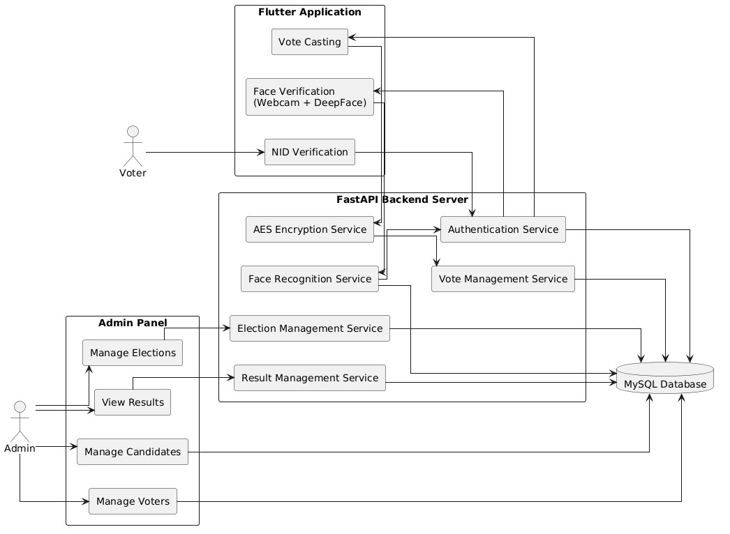
Figure 3.1: Proposed System Architecture of the Secure Electronic Voting System Using Biometric Authentication and AES Encryption

Figure 5.2: Face Verification Workflow
The Face Verification Workflow is a critical component of the proposed Secure Electronic Voting System. It ensures that only legitimate and registered voters are allowed to participate in the election process. The verification process begins when a voter enters a valid National Identity Number (NID) through the voting application. The system retrieves the corresponding voter information and registered facial image from the database.
After successful retrieval of voter data, the webcam is activated to capture a live facial image of the voter. The captured image undergoes preprocessing and is sent to the backend server for biometric authentication. The DeepFace face recognition model extracts facial features from both the live image and the stored voter photograph and compares them to determine their similarity.
If the similarity score exceeds the predefined threshold value, the voter is successfully authenticated and granted access to the voting interface. Otherwise, the authentication process fails, and the voter is denied access to vote. This mechanism effectively prevents voter impersonation, unauthorized access, and election fraud by ensuring that only the registered voter can cast a vote.
The face verification workflow enhances the security, reliability, and transparency of the electronic voting process by incorporating biometric authentication as an additional layer of protection beyond traditional identity verification methods.

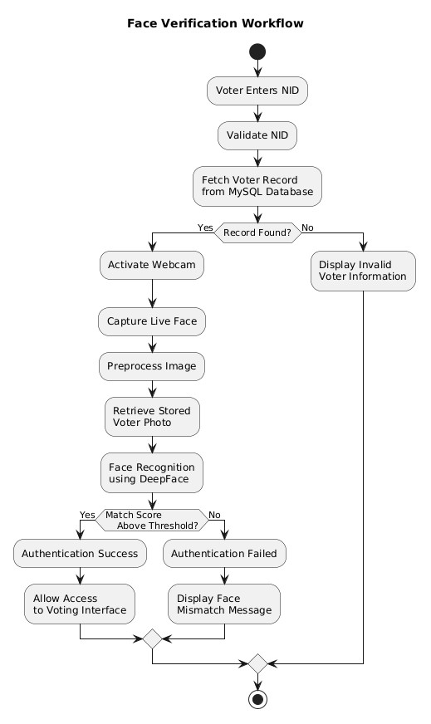
Figure 5.2: Face Verification Workflow of the Proposed Electronic Voting System

Figure 5.3: Secure Voting Process
The Secure Voting Process begins after a voter has been successfully authenticated through biometric face verification. Once the authentication is completed, the system grants the voter access to the voting interface, where a list of candidates participating in the election is displayed. The voter carefully reviews the available candidates and selects a preferred candidate to cast a vote.
Before accepting the vote, the system performs a validation check to confirm that the voter is eligible to participate in the election and has not previously cast a vote. This verification step is essential for preventing duplicate voting and ensuring that each voter can vote only once. If the voter has already submitted a vote, the system denies the voting request and displays an appropriate notification.
If the voter is eligible, the selected candidate information is converted into a vote record and processed through the Advanced Encryption Standard (AES) encryption module. AES encryption protects the vote from unauthorized access, modification, or disclosure during storage and transmission. The encrypted vote is then securely stored in the MySQL database through the Vote Management Service.
After successfully storing the encrypted vote, the system updates the voter’s status in the database to indicate that the voter has already participated in the election. Finally, a confirmation message is displayed to inform the voter that the vote has been successfully recorded. This secure voting workflow ensures vote confidentiality, data integrity, voter authenticity, and protection against election fraud.
The Secure Voting Process plays a vital role in maintaining the transparency and reliability of the proposed electronic voting system by combining biometric authentication with encryption-based data protection mechanisms.
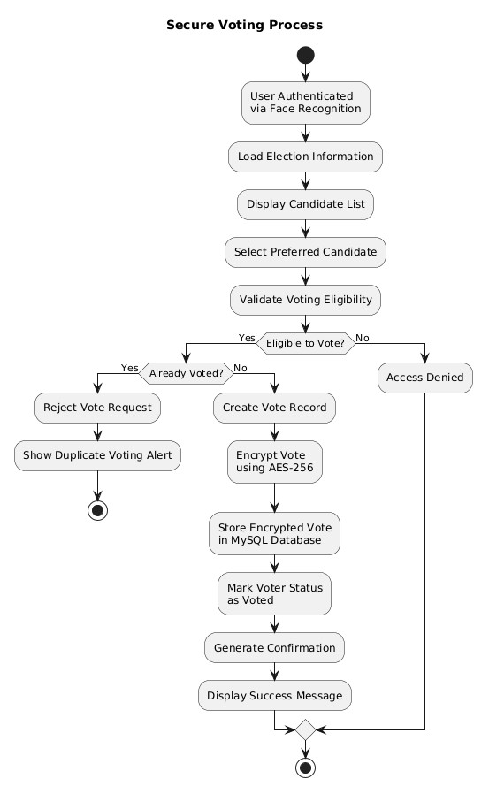
Figure 5.3: Secure Voting Process of the Proposed Electronic Voting System

6. Applications
The proposed Secure Electronic Voting System Using Biometric Authentication and AES Encryption can be applied in various sectors where secure, transparent, and reliable voting mechanisms are required. By integrating facial biometric verification and AES-based encryption, the system ensures voter authenticity, vote confidentiality, and election integrity.

Major Application Areas
- National Elections o Can be used in government elections to authenticate voters and prevent election fraud.
  - Ensures secure vote casting and transparent election management.
- University Election Systems o Suitable for conducting elections for student organizations, clubs, and university governance bodies.
  - Reduces manual effort and improves election efficiency.
- Student Representative Elections o Enables secure voting for selecting class representatives, department representatives, and student leaders.
  - Prevents unauthorized participation and duplicate voting.
- Corporate Voting Systems o Can be utilized for shareholder voting, board member elections, and organizational decision-making processes.
  - Ensures confidentiality and accuracy of voting results.
- Online Polling Platforms o Provides secure voter verification for online surveys, opinion polls, and public consultation programs.
  - Increases the credibility of collected responses.
- Government Digital Services o Supports e-governance initiatives by integrating secure identity verification and digital voting capabilities. o Can be used for public consultations, citizen feedback systems, and digital decision-making platforms.
- Professional and Non-Governmental Organizations
  - Useful for conducting committee elections, association voting, and member-based decision-making activities.
  - Ensures fairness, transparency, and accountability.
- Remote Voting Environments o Allows registered users to participate in voting activities from remote locations while maintaining strong security standards.
  - Reduces geographical barriers and increases participation.
The proposed system provides a secure, scalable, and efficient solution that can be adapted to various voting environments, ranging from small institutional elections to large-scale national election systems.

7. Required Resources
The successful implementation of the proposed system requires software resources, development tools, and computing devices.

7.1 Required Tools
Hardware
- Personal Computer/Laptop
- Webcam
- Internet Connection
Software
- Flutter SDK
- Python
- FastAPI
- DeepFace Library
- MySQL Server
- Visual Studio Code
- GitHub

8. Cost Estimation

8.1 Development Cost
Item | Cost (BDT)
Laptop and Accessories | Existing Resource
Internet Connection | 2,000
Database & Development Tools | Free/Open Source
Testing Resources | 1,500
Miscellaneous | 1,000
Total Estimated Cost | 4,500

8.2 Time Management
Activity | Jan | Feb | Mar | Apr | May | June
Literature Review | ✓ | ✓
System Design |  | ✓ | ✓
Database Design |  | ✓ | ✓
Frontend Development |  |  | ✓ | ✓
Backend Development |  |  | ✓ | ✓
Face Recognition Integration |  |  |  | ✓ | ✓
AES Implementation |  |  |  | ✓ | ✓
Testing |  |  |  |  | ✓ | ✓
Documentation |  |  |  |  | ✓ | ✓

References
- A. K. Jain, A. Ross, and S. Prabhakar, “An Introduction to Biometric Recognition,” IEEE Transactions on Circuits and Systems for Video Technology, vol. 14, no. 1, pp. 4– 20, Jan. 2004.
- F. Schroff, D. Kalenichenko, and J. Philbin, “FaceNet: A Unified Embedding for Face Recognition and Clustering,” in Proceedings of the IEEE Conference on Computer Vision and Pattern Recognition (CVPR), Boston, MA, USA, 2015, pp. 815–823.
- Y. Taigman, M. Yang, M. Ranzato, and L. Wolf, “DeepFace: Closing the Gap to Human-Level Performance in Face Verification,” in Proceedings of the IEEE Conference on Computer Vision and Pattern Recognition (CVPR), Columbus, OH, USA, 2014, pp. 1701–1708.
- O. M. Parkhi, A. Vedaldi, and A. Zisserman, “Deep Face Recognition,” in Proceedings of the British Machine Vision Conference (BMVC), Swansea, UK, 2015, pp. 1–12.
- D. Chaum, “Secret-Ballot Receipts: True Voter-Verifiable Elections,” IEEE Security & Privacy, vol. 2, no. 1, pp. 38–47, Jan.–Feb. 2004.
- B. Adida, “Helios: Web-Based Open-Audit Voting,” in Proceedings of the 17th USENIX Security Symposium, San Jose, CA, USA, 2008, pp. 335–348.
- A. Juels, D. Catalano, and M. Jakobsson, “Coercion-Resistant Electronic Elections,” in Proceedings of the ACM Workshop on Privacy in the Electronic Society, Alexandria, VA, USA, 2005, pp. 61–70.
- R. L. Rivest and W. D. Smith, “Three Voting Protocols: ThreeBallot, VAV, and Twin,” in Proceedings of the USENIX/ACCURATE Electronic Voting Technology Workshop, Vancouver, Canada, 2007.
- J. Galbally, S. Marcel, and J. Fierrez, “Biometric Anti-Spoofing Methods: A Survey in Face Recognition,” IEEE Access, vol. 2, pp. 1530–1552, 2014.
- National Institute of Standards and Technology (NIST), Advanced Encryption Standard (AES), Federal Information Processing Standards Publication 197, Gaithersburg, MD, USA, Nov. 2001.
- W. Stallings, Cryptography and Network Security: Principles and Practice, 8th ed. London, U.K.: Pearson Education, 2020.
- M. Bishop, Computer Security: Art and Science, 2nd ed. Boston, MA, USA: Addison-Wesley, 2018.
- S. Nakamoto, “Bitcoin: A Peer-to-Peer Electronic Cash System,” 2008. [Online].
Available: https://bitcoin.org/bitcoin.pdf
- Google, “Flutter Documentation.” [Online]. Available: https://docs.flutter.dev
- S. Ramírez, “FastAPI Documentation.” [Online]. Available: https://fastapi.tiangolo.com
- Oracle Corporation, “MySQL Reference Manual.” [Online]. Available: https://dev.mysql.com/doc/

